It aims to figure out the modules that should be in the system to fulfill all the system requirements in an efficient manner. The design will contain the specification of all these modules, their interaction with other modules and the desired output from each module. The output of the design process is a description of the software architecture.

The design phase is followed by two sub phases

* High Level Design
* Detailed Level Design

**4.2 System Architecture Diagram**

The figure 4.1 shows a general block diagram describing the activities performed by this application. The entire architecture has been implemented in nine modules which covers high level design and low level design.

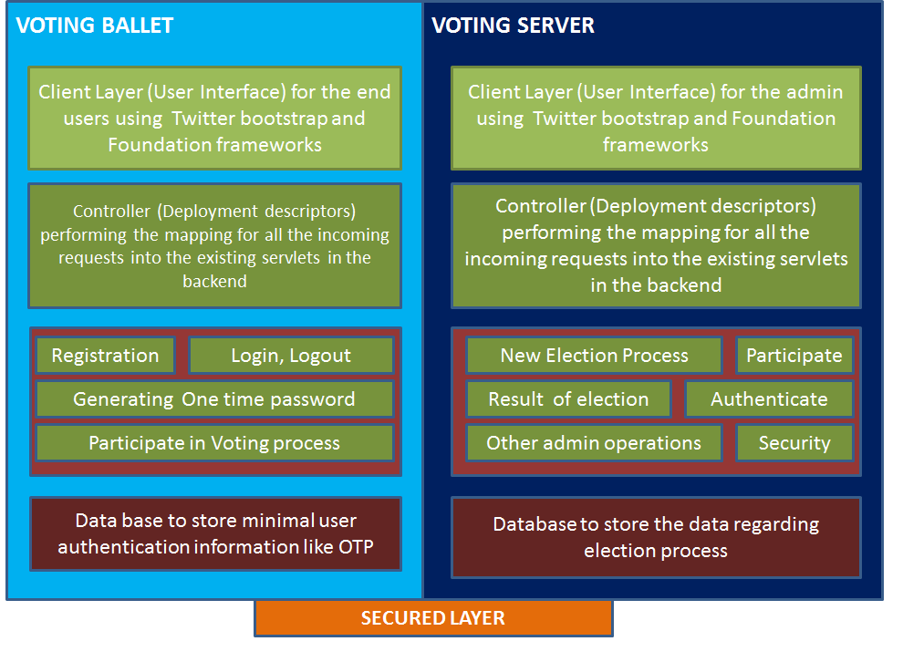

Figure 4.1 System Architecture

The two main components of the figure 4.1 are

* Voting Ballot
* Voting Server

**Voting Ballot**

Ballot uses the user interface for logic by the user which is designed using twitter bootstrap and foundation frame work. Then the deployment descriptor does the mapping of the requests to the existing servlets in the back end Then comes the layer which performs registration, login , logout, Casting a vote, entering the OTP Database layer to store the user interface information for authentication purpose like OTP

**Voting Server**

The user interface only for the admin which will be designed using the twitter bootstrap an foundation framework Deployment descriptor does the mapping of the requests to the existing servlets in the back end. Then comes the layer which has operations such as—New election process, Participate, results of the election, Authentication, Other admin operations and also security Database layer to store the data regarding the election process